Bielefelder Kennhuhn

Domestic chicken breed. The term “Kennhuhn” comes from the fact that male and female chicks have different drawn feathers and are therefore already recognizable on the first day of life.  The male chick shows on the approach of the fluff a light brown spine and a white sparrow on the head. The hen chick, however, is light brown with rich dark brown, almost black back stripes and a small sparrow hawk on the middle of the vertex. |  |  | 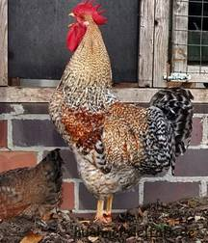
This chicken has only advantages over traditional breeds of chickens. It lays many large eggs, and the rich meat tastes great. |  |  |  | Origin |  | Germany
 |  |  |  | Year |  | 1976 / 1980
 |  |  |  | Weight |  | Male 3-4.5kg
 |  |  |  |  |  | Female 2.5-3.25kg
The chicken is very meaty, very tender. The chest is large and the hips are round and full of meat. It's the perfect chicken for the family, because the whole chicken is really big. |  |  |  | Eggs per year |  | 230 pieces
 |  |  |  | The color of the eggshell |  | Brown
 |  |  |  | Egg Weight |  | 60g
 |  |  | Standards |  |  | BDRG
The cock is perfect for coq au vin [a French dish that is fantastically aromatic], so it is also suitable for stewing.

The great advantage of this breed of chickens:

Very robust breed of chickens!
Certainly, you can collect the eggs under the chicken without getting pecked!
Winter hard breed - because the feathers are very tight!
Recognition of chicken and rooster on the first day of hatching!
Easy Feeding 12 - 15% Protein is enough!
Large eggs - tender soft meat!

